Java tutorial inference of code

There are 42 total steps
1.in the main function new object for electronic class has been created.

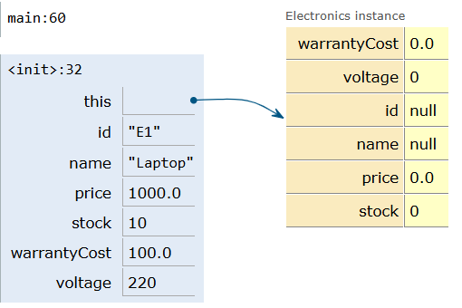
2. in the electronics constructor the attributes are inherited from parent class with super keyword.

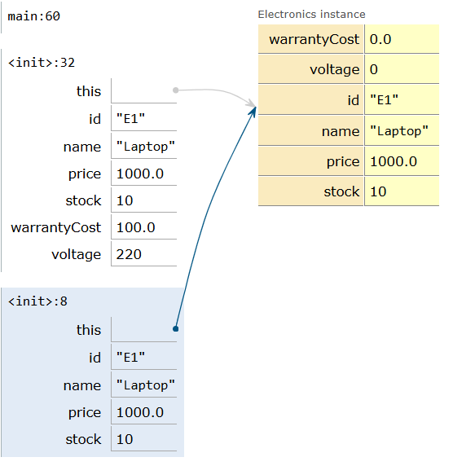
3-8.the attributes passed to parent(product) class from main are inherited from parent class and constructor intialises all the values using this function(constructor chaining)
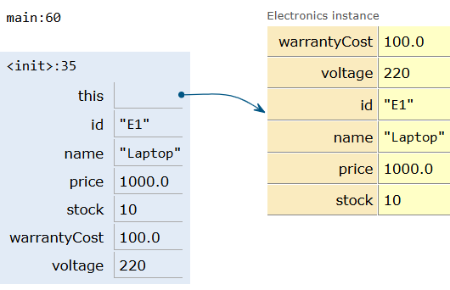
9-11.the warranty cost and voltage attributes are initialised from inheriting the parent class and initialised using this function.

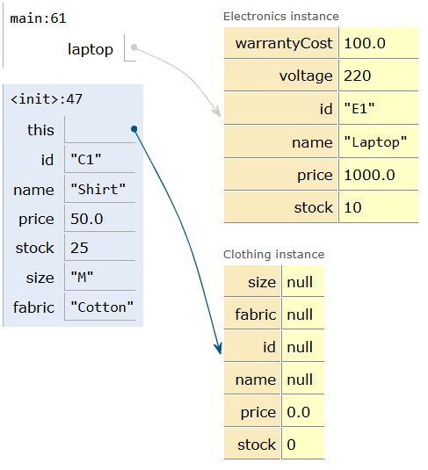
12.new object for clothing class is created.and actual parameters are parsed.
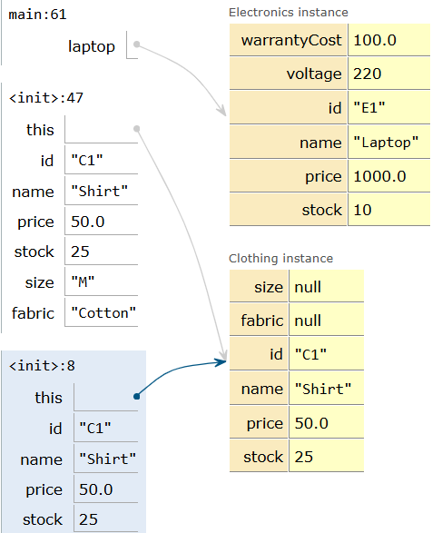
13-19.the clothing class inherits the attributes from parent class which got its value parsed from main using super keyword(constructor chaining)

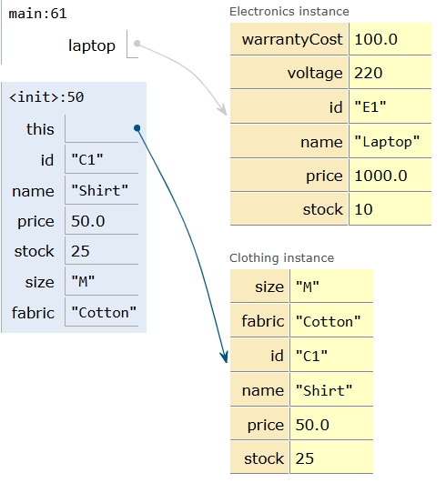
20-22.the size and fabric are also intialised after being parsed from main with this function
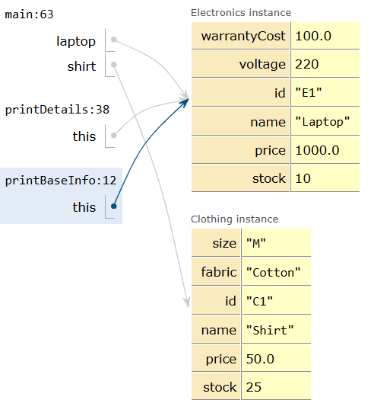
23-28.next in main the printdetails method of laptop is called (prints warranty and voltage) in which there is an other function printbaseinfo called from parent class using super function which prints id to stock
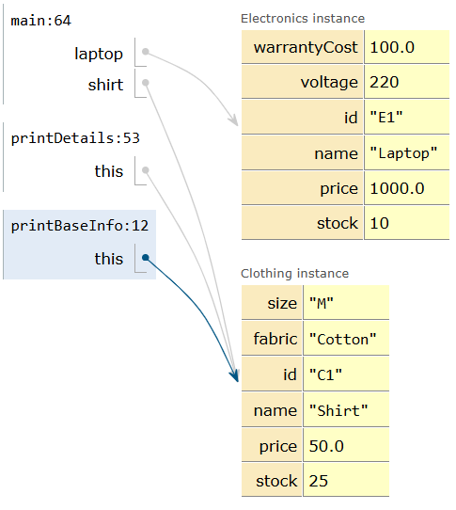
29-34.next In main the printdetails method ofshirt is called (prints size and fabric) in which there is an other function printbaseinfo from parent class using inheritance which prints id to stock
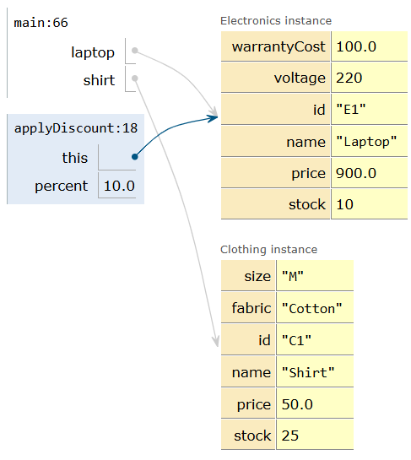
35-38.next in main the discount (overload function ) is called for laptop and only one argument is passed where a percent discount is applied and printed

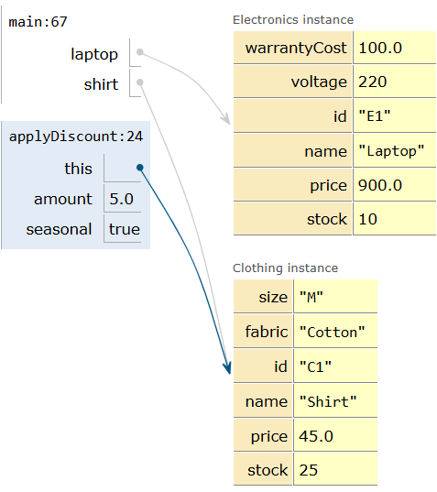
39-42.next in main the discount function for shirt with 2 attributes is passed and the flat discount is applied and printed
The java code:
class Product {
private String id, name;
private double price;
private int stock;

public Product(String id, String name, double price, int stock) {
this.id = id; this.name = name; this.price = price; this.stock = stock;
}

public void printBaseInfo() {
System.out.println("ID: " + id + ", Name: " + name + ", Price: $" + price + ", Stock: " + stock);
}

// Overload 1: Percentage discount
public void applyDiscount(double percent) {
price -= price * (percent / 100.0);
System.out.println(name + " price after " + percent + "% off: $" + price);
}

// Overload 2: Flat amount discount with seasonal flag
public void applyDiscount(double amount, boolean seasonal) {
price -= amount;
System.out.println((seasonal ? "[Seasonal] " : "") + name + " price after $" + amount + " off: $" + price);
}
}

class Electronics extends Product {
private double warrantyCost;
private int voltage;

public Electronics(String id, String name, double price, int stock, double warrantyCost, int voltage) {
super(id, name, price, stock); // Constructor chaining
this.warrantyCost = warrantyCost;
this.voltage = voltage;
}

public void printDetails() {
super.printBaseInfo(); // Parent method invocation using super
System.out.println("Warranty: $" + warrantyCost + ", Voltage: " + voltage + "V\n");
}
}

class Clothing extends Product {
private String size, fabric;

public Clothing(String id, String name, double price, int stock, String size, String fabric) {
super(id, name, price, stock); // Constructor chaining
this.size = size;
this.fabric = fabric;
}

public void printDetails() {
super.printBaseInfo(); // Parent method invocation using super
System.out.println("Size: " + size + ", Fabric: " + fabric + "\n");
}
}

public class Main {
public static void main(String[] args) {
Electronics laptop = new Electronics("E1", "Laptop", 1000.0, 10, 100.0, 220);
Clothing shirt = new Clothing("C1", "Shirt", 50.0, 25, "M", "Cotton");

laptop.printDetails();
shirt.printDetails();

laptop.applyDiscount(10.0);
shirt.applyDiscount(5.0, true);
}
}

Written by – Karthik.k.shetty and Akshay.singh

